MySQL:

1. Right click MySQL Server, select Create Database:

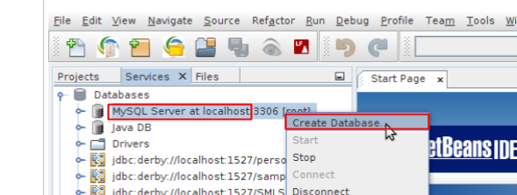

2. Fill the database name, select Grant Full Access To, and choose root@localhost, then click OK:

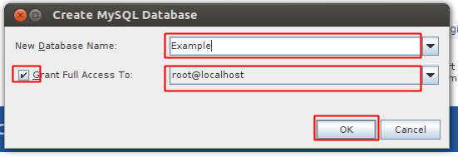

Java DB:

1. Right click Java DB, select Create Database:

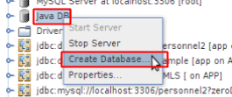

2. Fill the Database Name, User Name, Password, Confirm Password, then click OK

